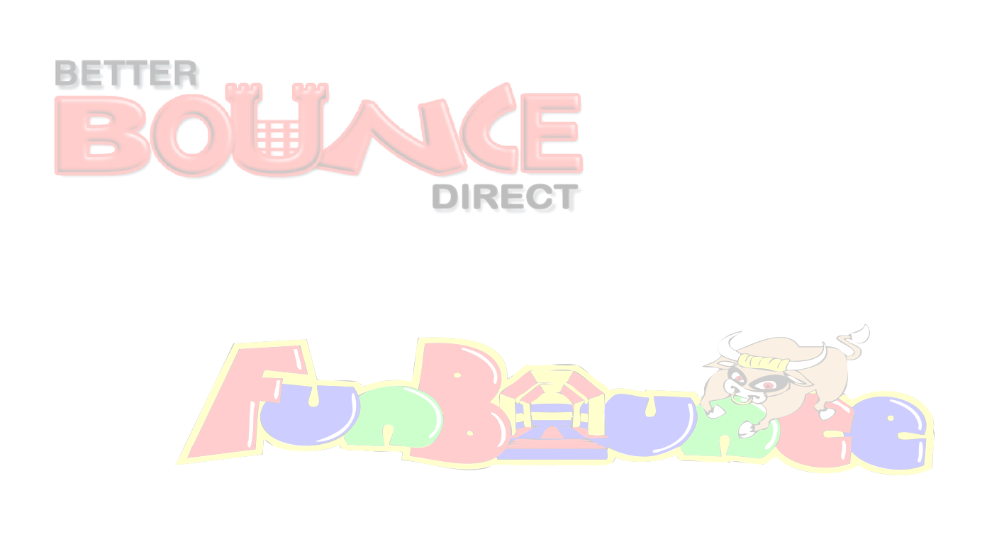
Risk Assessment – Inflatable Slide
Hazard Area | Risk | Existing Controls | Likelihood  1 - 5 | Severity  1 - 5 | Risk Score  L x S | Further Action to take
Inflatable Slide | Over enthusiastic participants | Responsible person supervising at all times. Rocking from side to side is NOT PERMITTED UNDER ANY CIRCUMSTANCES. No lap ringing on the slide permitted. | 2 | 1 | 1 | In the event of large numbers of participants trained operators will be supplied with the inflatable to aid with large numbers.
Inflatable Slide | Overloading or Tipping over. | No user weighing over 90kg or 14 stone is permitted to us the equipment at any time. | 1 | 5 | 5 | None
Inflatable Slide | Larger participants colliding with smaller participants | Responsible person supervising at all times. No lap ringing on the slide permitted. | 1 | 1 | 1 | Participants put into groups of similar size.
Inflatable Slide | Adverse weather conditions. | The item will be switched off in heavy rain and is not permitted to run in strong winds over 24mph as both these conditions can be deemed a health and safety risk. This risk must be used in conjunction with our weather-safety-advice document. | Dependant on weather | Dependant on weather | Dependant on weather | Use a wind speed meter at all times and close the equipment when predicted speeds are over 24mph including gusts. Use the met office for data; https://www.metoffice.gov.uk/public/weather/forecast
Inflatable Slide | Injury through lack of supervision. | At least 2 fully trained operators must be present with the equipment at all times, 2 per entrance and exit is advised. | 1 | 5 | 5 | In the event that the supervisors must leave there post, Equipment must be switched off and not used.
Inflatable Slide | Danger of injury from hard surfaces. | The inflatable must never be mounted unless the inflatable bed is fully inflated whether the inflatable is in operation or not as this can lead to serious injury. | 1 | 4 | 4 | None
Inflatable Slide | Tripping over anchorage points, spare equipment, electrical cables | Anchor points used as per manufacturers instructions and spare equipment erected safely or stowed away. Where possible electrical cable does not cross any public pathway. | 1 | 1 | 1 | In the event of large numbers of participants attending or large events, additional safety fencing is erected, electrical cables will be erected overhead or covered and
Inflatable Slide | Injury through incorrect positioning. | Do not move or try to reposition the inflatable under any circumstances and ensure that the anchors are in place at all times. | 1 | 2 | 2 | None
Inflatable Slide | Petrol Blower, Generator  Risk of fire | Blowers/generators filled with fuel before delivery, units are fire retardant. | 1 | 2 | 2 | All spare fuel is stored in suitable marked container, and in a safe location, units switched off during re fuelling,
Inflatable Slide | Choking | No food drinks or chewing gum to be allowed on or near the Inflatable. | 1 | 4 | 4 | None
Inflatable Slide | Injury through 3rd party items | All shoes, glasses, jewellery, badges MUST be removed before using this Inflatable. | 1 | 5 | 5 | None
Inflatable Slide | Danger of fire. | No smoking or barbecues near the Inflatable at any time. | 1 | 5 | 5 | None
Inflatable Slide | Danger of falling from height. | Climbing, hanging or sitting on walls is DANGEROUS and must not be allowed at any time, All our beds have low walls for supervision purposes, this rule is exceptionally important when the inflatable is erected on hard surfaces. | 1 | 3 | 3 | None
Inflatable Slide | Injury through 3rd party & spectators. | Always ensure that the area surrounding the Inflatable is not overcrowded. | 2 | 3 | 6 | None
Inflatable Slide | Emergency | In the event that someone is seriously injured, DO NOT move the individual, leave the inflatable switched on and dial 999 immediately. | N/a | N/a | N/a | N/a
Inflatable Slide | Injury through Rope or netting | Rope or netting should be supervised to ensure participants do not become tangled.  Supervisor should be provided at all time. | 1 | 3 | 3 | None
Inflatable Slide | Injury through lack of inflatable pressure or suffocation. | Do not allow anyone to be on the Inflatable during inflation or deflation as this can be EXTREMELY DANGEROUS. Entrance must be supervised by 2 people at all times | 1 | 2 | 2 | None
Inflatable Slide | Injury through insecure anchorage. | Never use this unit without proper anchorage in place, It may be blown over in certain wind conditions, If the inflatable unit is not anchored correctly please ensure you tell the erection team before they leave as we keep a tight schedule and may not be able to return immediately. | 1 | 5 | 5 | None

L=Likelihood S=Severity L*S= Risk 1=Low 5=High
Risk is worked out using numbers 1 - 5. The likelihood is given a number and this is multiplied by the number given to the severity of the risk.
The result = the risk factor. This generic risk assessment is brief and we have our own individual assessments for each individual risk, 25 being the worst possible outcome, any item reaching 25 would give serious cause for concern & we would not be able to erect the unit. It is recommended that clients undertake their own risk assessment to suit their requirements.

